**Virtual Lab**

**Numerical aperture of Optical Fiber**

**Expt. 02**

**Name: Ayush Jain**

**SAP ID: 60004200132**

**Branch: Computer Engineering**

**Aim:**

To find the numerical aperture of a given optic fibre and hence to find its acceptance angle.

**Apparatus:**

Emitter, concentrator, fibre, fibre stand, detector and output unit.

**Diagram:**

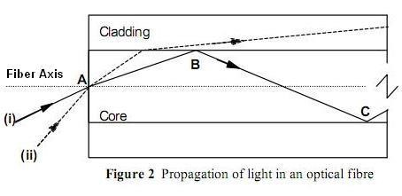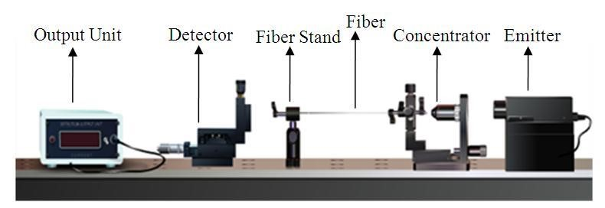

Experimental Set-up

**Theory:**

Optical fibers are fine transparent glass or plastic fibers which can propagate light. They work under the principle of total internal reflection from diametrically opposite walls. In this way light can be taken anywhere because fibers have enough flexibility. This property makes them suitable for data communication, design of fine endoscopes, micro sized microscopes etc. An optic fiber consists of a core that is surrounded by a cladding which are normally made of silica glass or plastic. The core transmits an optical signal while the cladding guides the light within the core. Since light is guided through the fiber it is sometimes called an optical wave guide.

In order to understand the propagation of light through an optical fibre, consider the figure (2)(**Diagram**). Consider a light ray (i) entering the core at a point A , travelling through the core until it reaches the core cladding boundary at point B. As long as the light ray intersects the core-cladding boundary at a small angles, the ray will be reflected back in to the core to travel on to point C where the process of reflection is repeated .ie., total internal reflection takes place. Total internal reflection occurs only when the angle of incidence is greater than the critical angle. If a ray enters an optic fiber at a steep angle(ii), when this ray intersects the core-cladding boundary, the angle of intersection is too large. So, reflection back in to the core does not take place and the light ray is lost in the cladding. This means that to be guided through an optic fibre, a light ray must enter the core with an angle less than a particular angle called the acceptance angle of the fibre. A ray which enters the fiber with an angle greater than the acceptance angle will be lost in the cladding.

Consider an optical fibre having a core of refractive index n1 and cladding of refractive index n2. let the incident light makes an angle i with the core axis as shown in figure (3). Then the light gets refracted at an angle *θ* and fall on the core-cladding interface at an angle where,

 ---------------------- (1)

By Snell’s law at the point of entrance of light in to the optical fiber we get,

 -------------------- (2)

Where n0 is refractive index of medium outside the fiber. For air n0 =1.

When light travels from core to cladding it moves from denser to rarer medium and so it may be totally reflected back to the core medium if *θ'* exceeds the critical angle *θ'*c. The critical angle is that angle of incidence in denser medium (n1) for which angle of refraction become 90°. Using Snell’s laws at core cladding interface,



Or

 ----------------------- (3)

Therefore, for light to be propagated within the core of optical fiber as guided wave, the angle of incidence at core-cladding interface should be greater than *θ'*c. As i increases, *θ* increases and so *θ'* decreases. Therefore, there is maximum value of angle of incidence beyond which, it does not propagate rather it is refracted in to cladding medium ( fig: 3(b)). This maximum value of i say im is called maximum angle of acceptance and n0 sin im is termed as the numerical aperture (NA).

From equation(2),



From equation (2) 

Therefore,

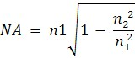

The significance of NA is that light entering in the cone of semi vertical angle im only propagate through the fibre. The higher the value of im or NA more is the light collected for propagation in the fibre. Numerical aperture is thus considered as a light gathering capacity of an optical fibre.

Numerical Aperture is defined as the Sine of half of the angle of fibre’s light acceptance cone. i.e. NA= Sin θa where θa, is called acceptance cone angle.

Let the spot size of the beam at a distance d (distance between the fiber end and detector) as the radius of the spot(r). Then,

----------------------- (4)

**Working Process:**

**Preliminary Adjustment:**

* Drag and drop each apparatus in to the optical table.
* Then Click “Start” button.
* Switch On (now you can see a spot in the middle of the detector)
* After that select the Fiber and Laser for performing the experiment from the control options.

**To perform the experiment:**

* Set the detector distance Z (say 4mm). We referred the distance as “d” in our calculation.
* Vary the detector distance X by an order of 0.5mm, using the screw gauge (use up and down arrow on the screw gauge to rotate it).
* Measure the detector reading from output unit and tabulate it.
* Plot the graph between X in x-axis and output reading in y-axis. See figure 5.
* Find the radius of the spot r, which is corresponding to Imax/2.71 (See the figure 5).

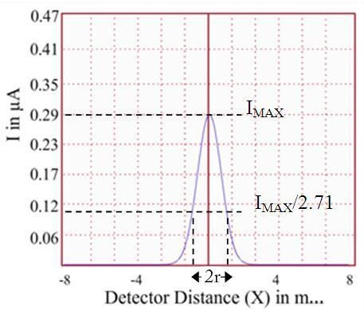 **Fig.5**

* Then find the numerical aperture of the optic fiber using the equation (4).

**Observations:**

|  |  |  |  |  |  |
| --- | --- | --- | --- | --- | --- |
| SR NO. | SCREW GAUGE READING | | DISTANCE (X) mm | I  (µA) | |
|  | H.S.R | P.S.R |  |  |
| 1. | 32 | 3.0 | 3.64 | 0.000126299 |
| 2. | 19 | 4.0 | 4.38 | 0.049630472 |
| 3. | 5 | 5.0 | 5.10 | 0.161114465 |
| 4. | 39 | 6.0 | 6.78 | 0.006048783 |
| 5. | 31 | 7.0 | 7.62 | 0.000001043 |

**Calculations:**

Distance between the fiber and the detector, d = **0.004 mm** Radius of the spot, **r= 0.00135 m**

Numerical Aperture of the optic fiber, sin(θ)= = **0.3198**

=

**18.65**

**degrees**



Acceptance angle, θ=

**Result:**

Numerical aperture of the optic fiber is = 0.3198

Angle of acceptance = 18.65 degrees

**My observations:**

